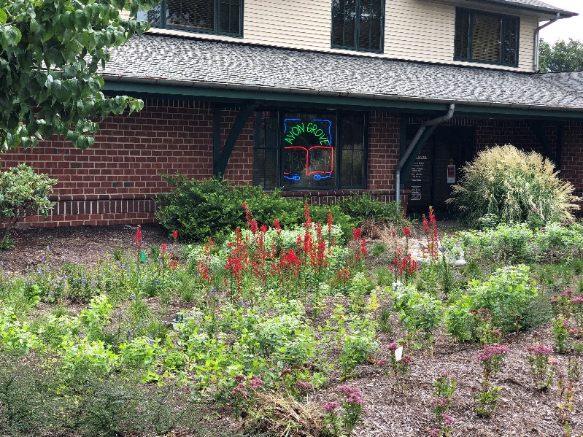
Rain Garden, Avondale Library
Looking for a Green Alternative to Stormwater Infrastructure?
Consider Green Stormwater Infrastructure (GSI)!
GSI practices attempt to mimic the natural water cycle by promoting infiltration at the source of stormwater run-off, slowing it down and recharging our natural ground water systems.
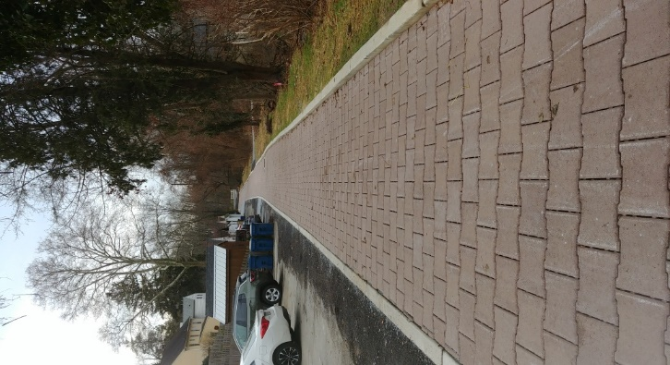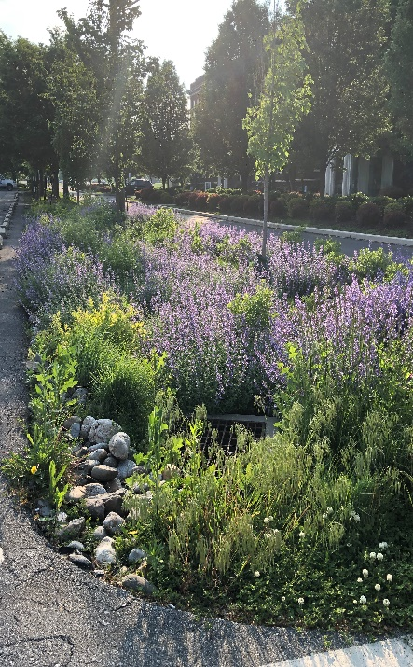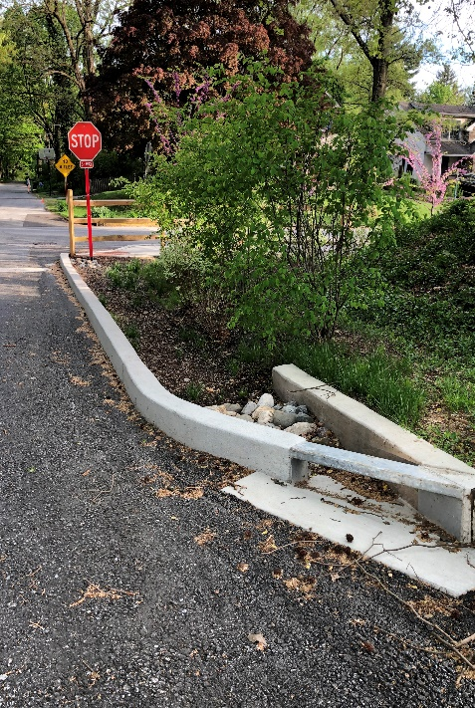
Permeable pavers Bioswale Stormwater Bumpout
Download the Guide to Green Stormwater Infrastructure to learn more at https://cwmp.org/homeowner_resources/
For more information about stormwater infrastructure contact your municipality at (municipality, phone, email)

